Task 4: Designing and Modelling Deliverable
Package Diagram
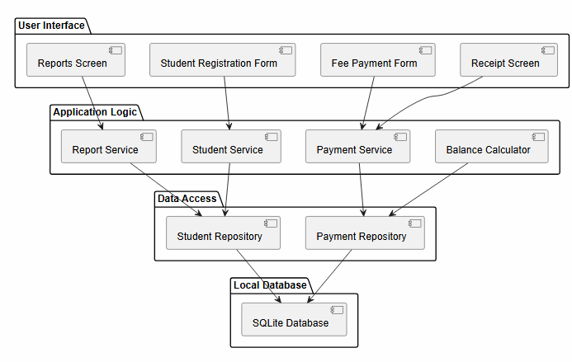
This package diagram shows the software architecture of the Kina Ridge Fee Management System. The system is divided into four logical layers: User Interface, Application Logic, Data Access, and Local Database. The User Interface contains screens such as the Reports Screen, Student Registration Form, Fee Payment Form, and Receipt Screen, which are used by staff to interact with the system. These screens send requests to services in the Application Logic layer, including the Report Service, Student Service, Payment Service, and Balance Calculator. The Data Access layer contains repositories that manage communication with the SQLite database. The arrows illustrate the flow of information through the layers, ensuring that users cannot directly access the database. This design follows a layered architecture pattern, improving maintainability, security, and system organization.

Deployment Diagram
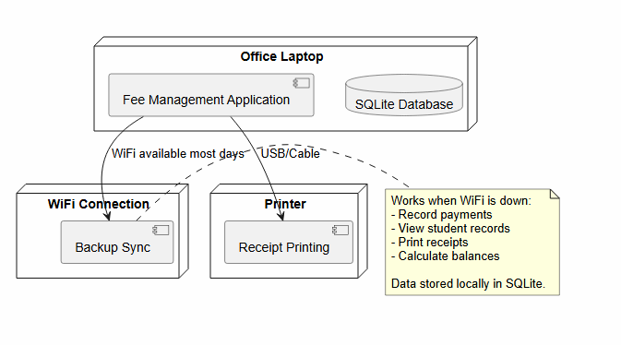
This deployment diagram shows the physical implementation of the Fee Management System. The main software application and SQLite database are installed on the school's office laptop, which serves as the primary device for fee management activities. A printer is connected to the laptop through a cable or USB connection and is used to print receipts for payments. The diagram also includes a WiFi connection that supports backup synchronization when network access is available. A note highlights the system's offline capabilities, showing that staff can continue recording payments, viewing student records, printing receipts, and calculating fee balances even when WiFi is unavailable. This deployment design supports the school's requirement for reliable operation in environments with limited or unstable internet connectivity.

Use Case Diagram
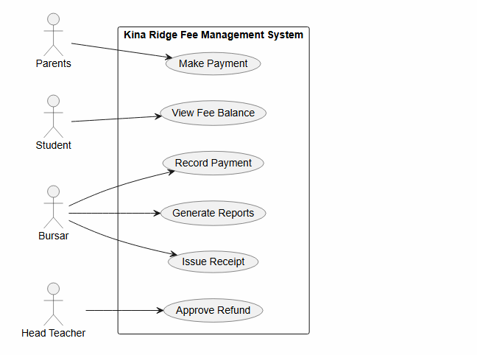
This use case diagram illustrates the interactions between users and the Kina Ridge Fee Management System. The actors are Parents, Students, Bursars, and the Head Teacher, each performing different functions within the system. Parents can make fee payments, students can view their fee balances, and bursars are responsible for recording payments, generating reports, and issuing receipts. The Head Teacher has the authority to approve refunds. The rectangle represents the system boundary, showing which activities are handled by the system. This diagram helps identify the functional requirements of the system and demonstrates role-based access control, ensuring that users can only perform actions appropriate to their responsibilities.

Class Diagram
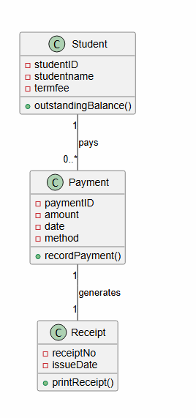
This class diagram represents the main data objects used in the Kina Ridge Fee Management System and the relationships between them. The three classes are Student, Payment, and Receipt. The Student class stores information such as student ID, student name, and term fee, and includes an operation to calculate the outstanding balance. The Payment class records payment information including payment ID, amount, date, and payment method, while the Receipt class stores receipt details and provides a function for printing receipts. The relationship labelled "pays" shows that one student can make multiple payments (0..*), while each payment is associated with one student. The relationship labelled "generates" indicates that every payment produces exactly one receipt. This diagram illustrates how fee-related information is organized and managed within the system.

State Diagram
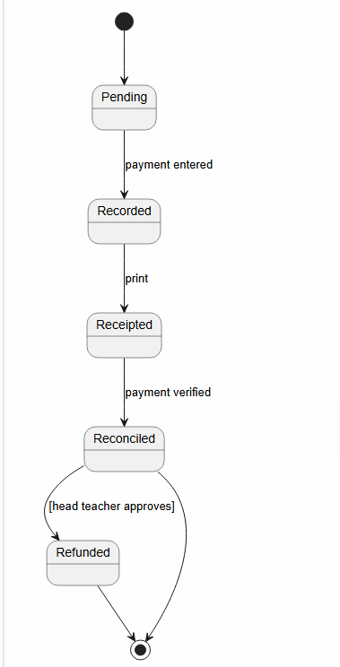
This state diagram illustrates the lifecycle of a payment transaction within the Kina Ridge Fee Management System. The process begins in the Pending state when a payment is initiated. Once the payment information is entered, it moves to the Recorded state. After a receipt is printed, the payment enters the Receipted state. When the payment has been verified, it transitions to the Reconciled state. From there, the transaction either successfully ends or moves to the Refunded state if the business rule [head teacher approves] is satisfied. The diagram demonstrates how payment processing follows a controlled sequence of states and ensures that refunds can only occur after proper authorization, providing accountability and financial control.

Activity Diagram
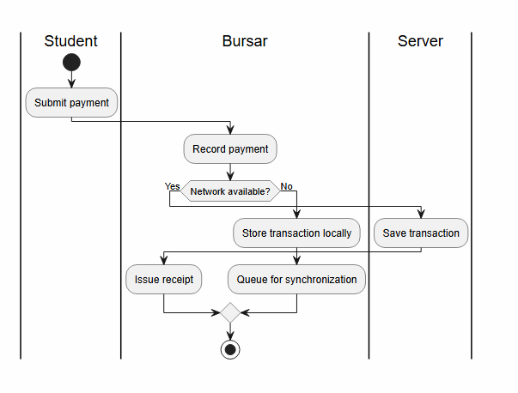
This activity diagram models the workflow for processing student fee payments and shows how different participants interact throughout the process. The process begins in the Student swimlane when a student submits a payment. The activity then moves to the Bursar swimlane, where the bursar records the payment. A decision point checks whether the network is available. If the network is available, the transaction is saved directly on the server. If the network is unavailable, the payment is stored locally and queued for synchronization when connectivity is restored. After either path is completed, the bursar issues a receipt and the process ends. This diagram highlights the system's offline capability, ensuring that payment processing can continue even when internet connectivity is unavailable, which is important for schools operating in areas with unreliable network access.

